Figures

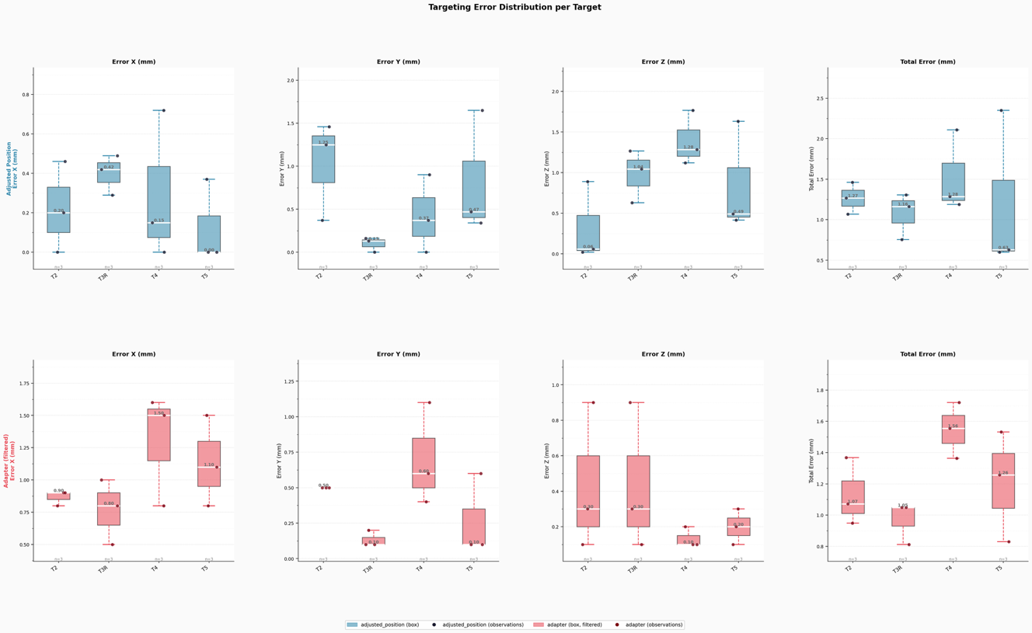Figure 1. Targeting error distribution per target for each spatial error metric.
Box plots displaying the distribution of targeting errors across individual targets for four error metrics — Error X, Error Y, Error Z, and Total Error (mm) — under two experimental conditions: the standard adjusted-position phantom setup (top row) and the adapter attachment setup (bottom row). Each box represents the interquartile range (IQR); whiskers extend to the full data range (0th–100th percentile). Overlaid scatter points (jittered horizontally for clarity) represent individual operator measurements. White horizontal lines within each box denote the median, with the median value annotated above. Sample sizes (n) are indicated at the base of each group. The adapted position setup uses integer-coded operators (1, 2, 3); rows in which both collar and arc values were absent or zero were excluded prior to analysis.

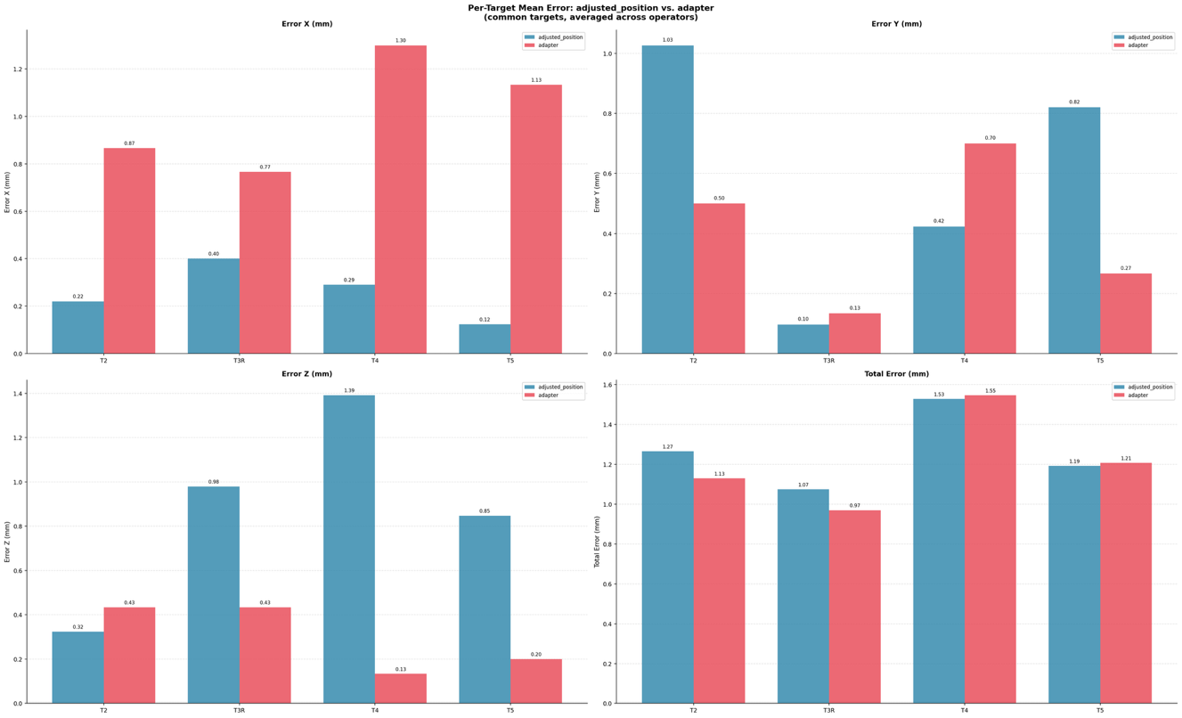Figure 2. Per-target mean targeting error comparing the adjusted-position and adapter setups.
Grouped bar charts showing the mean targeting error for each target, averaged across all operators, under the adjusted-position (blue) and adapter (red) experimental conditions. Results are presented separately for Error X, Error Y, Error Z, and Total Error (mm). Only targets common to both datasets are included. Numerical values are annotated above each bar. This comparison directly quantifies the effect of the adapter attachment on spatial targeting accuracy across individual targets and error axes.

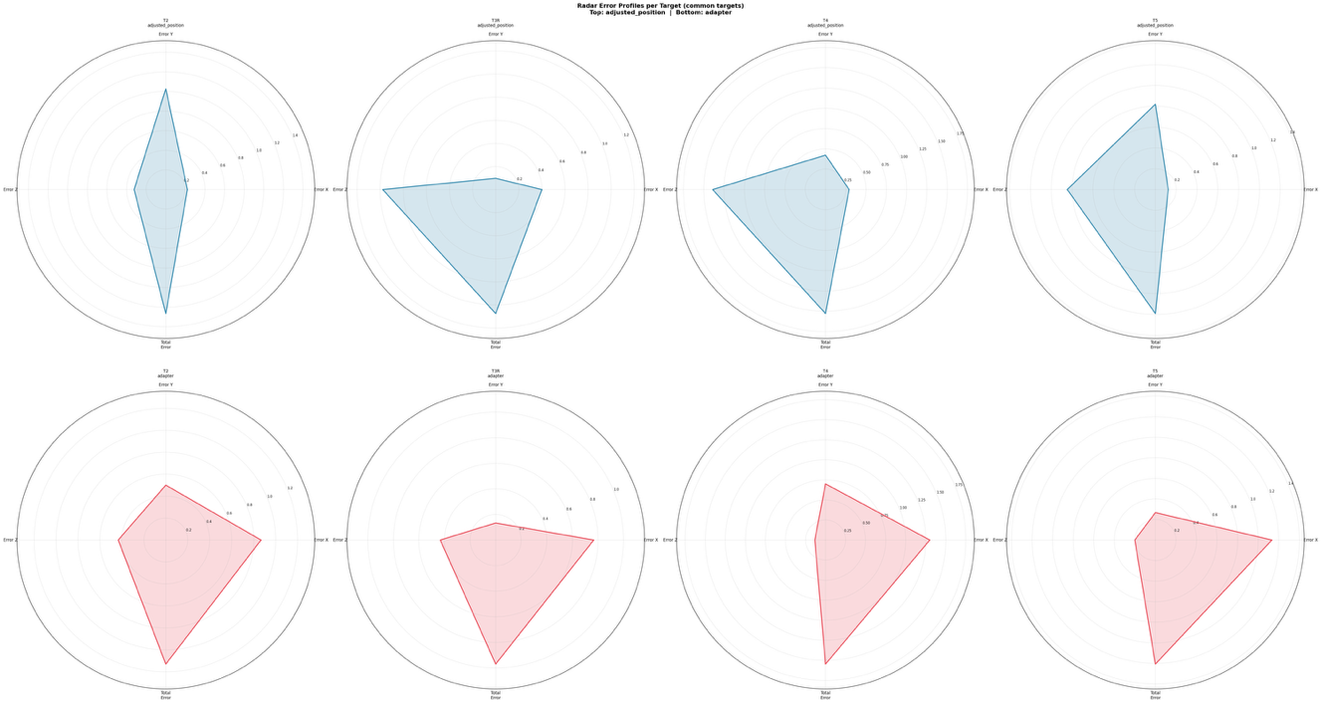Figure 3. Radar error profiles per target under both experimental conditions.
Polar (radar/spider) charts illustrating the multi-dimensional error profile of each target for the four-error metrics: Error X, Error Y, Error Z, and Total Error (mm). Each panel corresponds to a single target; the top row shows profiles from the adjusted-position setup and the bottom row from the adapter setup. The radial extent of the shaded polygon reflects the magnitude of error along each axis. This representation enables rapid visual comparison of the error "shape" — i.e., which spatial axes contribute most — both within and between experimental conditions.

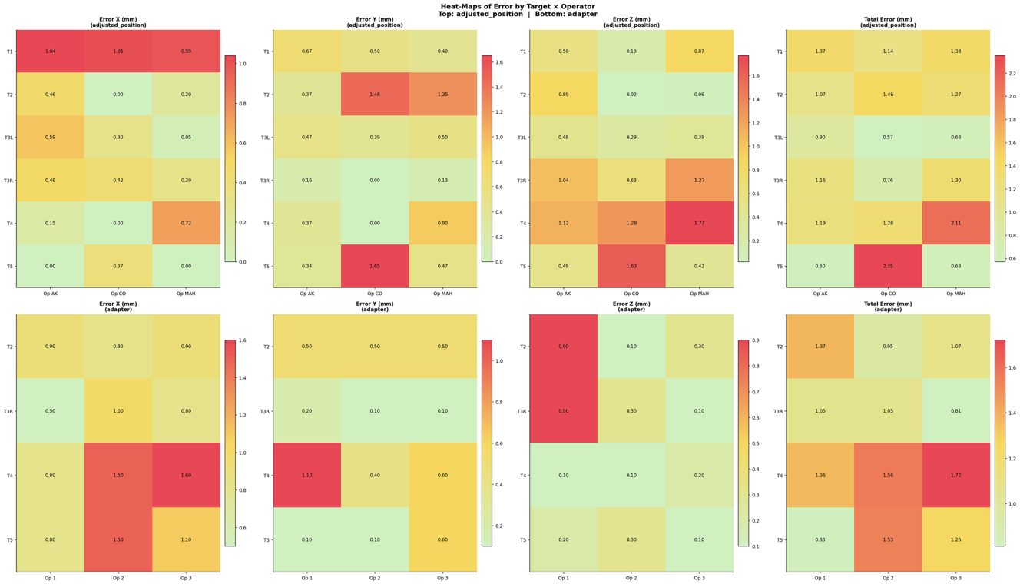Figure 4. Heat-maps of targeting error by target and operator.
Color-encoded heat-maps displaying mean targeting error as a function of target identity (rows) and operator (columns) for each of the four-error metrics. The top row corresponds to the adjusted-position setup; the bottom row corresponds to the adapter setup. Cell color ranges from green (low error) through yellow to red (high error), with numeric values overlaid on each cell. These maps facilitate identification of operator-specific or target-specific systematic biases and highlight whether measurement variability is attributable to individual operators or inherent target characteristics.

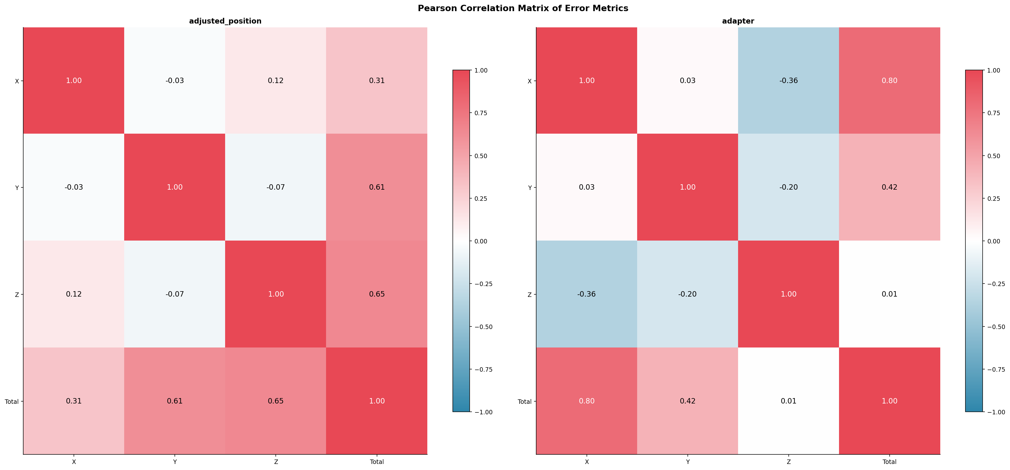Figure 5. Pearson correlation matrices of targeting error metrics.
Symmetric heat-maps showing pairwise Pearson correlation coefficients among the four-error metrics (Error X, Error Y, Error Z, Total Error) for the adjusted-position setup (left) and the adapter setup (right). Color encodes correlation strength and direction: red indicates strong positive correlation, white indicates no correlation, and blue indicates negative correlation. Numeric coefficients are overlaid on each cell. A strong positive correlation between component-axis errors and Total Error is expected by construction; cross-axis correlations indicate the presence of systematic directional biases in the targeting procedure.

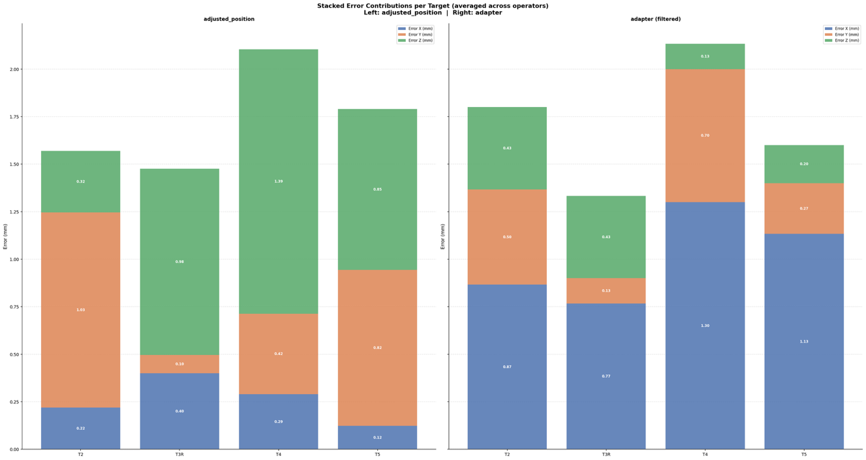Figure 6. Stacked-bar decomposition of spatial error contributions per target.
Stacked bar charts illustrating the relative contribution of each spatial error component — Error X (blue), Error Y (orange), and Error Z (green) — to the cumulative targeting error for each target, averaged across operators. Results for the adjusted-position setup are shown on the left and for the adapter setup on the right; only targets common to both conditions are included. Segment values are annotated within each bar. This figure reveals which spatial axis dominates targeting inaccuracy and whether the directional error pattern is preserved or altered by the introduction of the adapter.

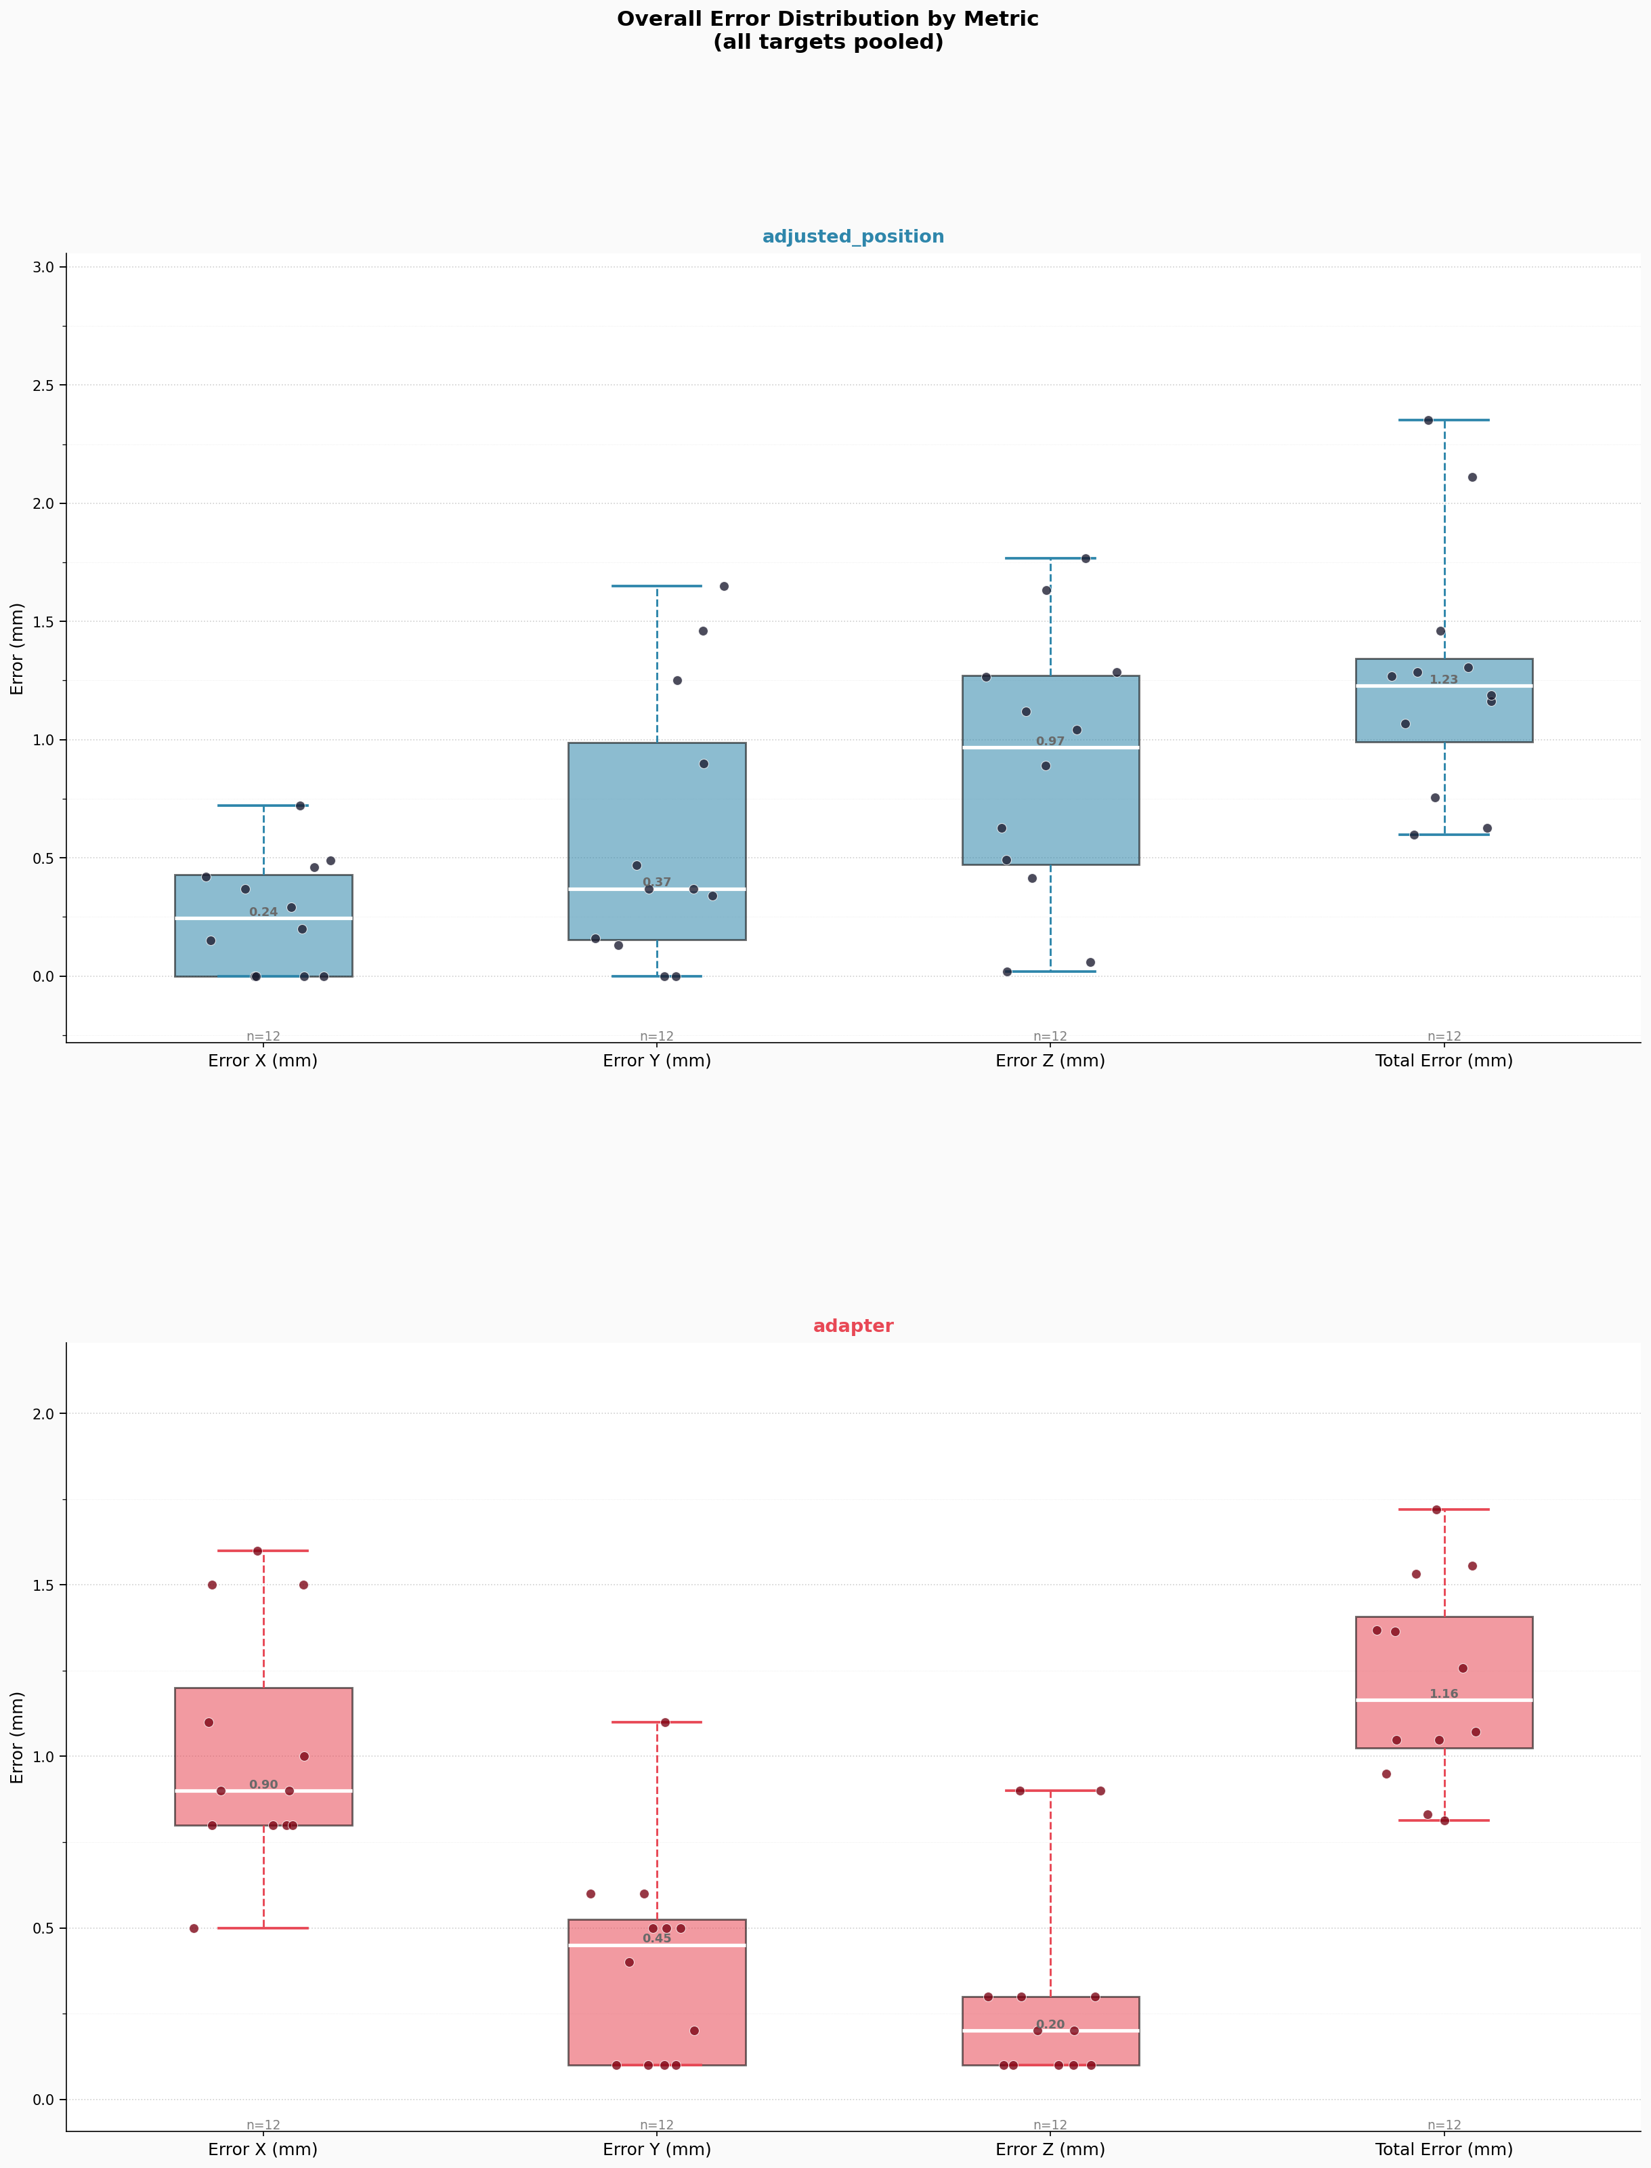Figure 7. Overall targeting error distribution pooled across all targets.
Box plots summarizing the aggregate distribution of targeting errors across all targets and operators for each of the four-error metrics under the adjusted-position setup (top) and the adapter setup (bottom). Each box represents the IQR; whiskers span the full observed range. Overlaid jittered points represent individual measurements, and median values are annotated. Sample sizes (n) are shown at the base of each group. This panel provides a concise, single-panel comparison of the overall error magnitude and variability across error axes, enabling direct assessment of total measurement performance under each experimental condition.

